

**JADORE**

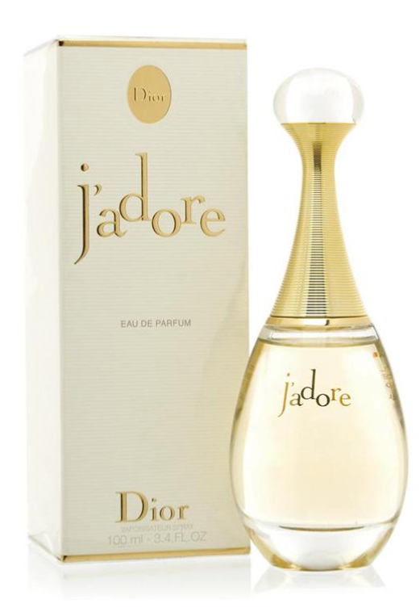**J'adore** by **Dior** is a Floral Fruity fragrance for women. **J'adore** was launched in 1999. The nose behind this fragrance is Calice Becker. Top notes are Pear, Melon, Magnolia, Peach, Mandarin Orange and Bergamot; middle notes are Jasmine, Lily-of-the-Valley, Tuberose, Freesia, Rose, Orchid, Plum and Violet; base notes are Musk, Vanilla, Blackberry and Cedar.

J’adore is a modern, glamorous fragrance, which has become incredibly popular, and for that reason developed in number of variants of different concentrations. J’adore is a luminous fragrance. Its opulent, golden scent shimmers on skin like sunbeams. The classic and ambitions of this fragrance reflects in the bottle shaped like Greek amphora. J’adore presents a new conception of Dior feminity, a scent so new and so in line with Dior style at the same time – sweet but balmy, slightly sharp floral with fresh mandarin in the top; jasmine, plum, orchid and rose in the heart; and amaranth, musk and blackberry in the trail. It was created in 1999.